End-to-End E-commerce Analytics
Sales, Customer Experience & Operational Performance

Prepared by:
Shreeya Mannuru

Document:
Data Preparation

Version:
1.0

Date:
August 2026

Table of Contents

S.No | Title | Page No.
1. | Dataset Overview | 4
2. | Data Model | 4
3. | Data Quality Assessment | 6
4. | Data Cleaning | 6
5. | Business Feature Engineering | 7
6. | Data Validation | 8
7. | Dataset Considerations and Limitations | 9
8. | Conclusion | 10

List of Figures

S.No | Title | Page No.
1. | Logical Data Model of the Olist  E-commerce Dataset | 4

List of Tables

S.No | Title | Page No.
1. | Key Tables in the Dataset | 5

1. Dataset Overview
The project uses the Olist Brazilian E-commerce Dataset, which contains anonymized information from an e-commerce marketplace in Brazil. The dataset covers multiple aspects of marketplace activity, including: Customers, Orders, Order items, Products, Sellers, Payments, Customer reviews.
The data provides an opportunity to analyze sales performance, customer behavior, product performance, delivery operations, payment behavior, and customer satisfaction.

2. Data Model
The analysis uses seven primary analytical tables:
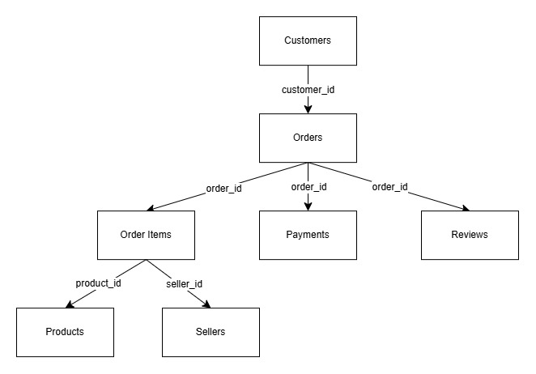
Figure 1. Logical Data Model of the Olist E-commerce Dataset
The analytical model connects customers, orders, order items, products, sellers, payments and reviews. The model considers the different levels of granularity between order-level and order-item-level data.
Table | Purpose
Customers | Customer and geographic information
Orders | Order lifecycle and timestamps
Order Items | Products purchased and transaction-level item values
Products | Product attributes and categories
Sellers | Seller information and location
Order Payments | Payment methods, installments and payment values
Order Reviews | Customer review scores and review information
Table 1. Key Tables in the Dataset
Two supporting tables are also available:
- Geolocation
- Product category translation
These supporting tables were not included in the primary analytical model because they were not required for the Version 1 business questions.
Core Relationships
The analytical model connects:
- Customers → Orders
- Orders → Order Items
- Products → Order Items
- Sellers → Order Items
- Orders → Order Payments
- Orders → Order Reviews
The model considers the different levels of granularity between order-level and order-item-level data.
3. Data Quality Assessment
The datasets were assessed for:
- Missing values
- Duplicate records
- Invalid data types
- Inconsistent categorical values
- Date consistency
- Order-status consistency
- Referential integrity
- Orphan records
Missing-value analysis was performed to identify fields where incomplete data could affect analysis.
Not every missing value was automatically removed because missingness can be meaningful in an e-commerce dataset. For example, certain delivery-related fields may legitimately be unavailable for orders that were not delivered.

4. Data Cleaning
The following cleaning activities were performed:
Date and Time Handling
Relevant timestamp fields were converted into appropriate datetime formats.
Date-derived fields were created where required for:
- Monthly analysis
- Delivery-time analysis
- Order lifecycle analysis
Delivery Time
Delivery duration was calculated using the relevant order timestamps.
The analysis focuses on completed/delivered orders when calculating delivery performance.
Missing Values
Missing values were handled based on their analytical importance rather than applying a blanket deletion approach.
Records were retained where missing values represented legitimate business conditions.
Duplicates
Duplicate records were assessed using appropriate identifiers such as:
- order_id
- order_item_id
- product_id
- seller_id
- review_id
Order Status
Order status was considered when calculating business KPIs.
For example, completed sales revenue and delivery performance are based on delivered orders, rather than treating cancelled or incomplete orders as completed sales.

5. Business Feature Engineering
Simple business-oriented features were created to make the data more useful for analysis.
Delivery Days
Measures the number of days between relevant order and delivery timestamps.
Business use:
Helps evaluate fulfillment performance and identify potential delivery issues.
Purchase Month
Groups orders into monthly periods.
Business use:
Supports trend analysis of revenue and order volume.
Approval/Processing Duration
Where applicable, order lifecycle timestamps can be used to assess the time taken between order placement and approval.
Business use:
Provides visibility into operational processing.
These features were designed around specific business questions rather than creating unnecessary derived variables.

6. Data Validation
After cleaning, the data was validated to ensure that:
- Expected tables existed in the database.
- Row counts were consistent with the cleaned datasets.
- Primary identifiers were populated where expected.
- Relationships between key tables were valid.
- Orphan records were checked.
- Delivered-order calculations used the appropriate order status.
- KPI calculations produced reasonable results.

Orphan Records
An orphan record is a record that references another record that does not exist in the related table.
For example, an order_items record referencing an order_id that does not exist in orders would be an orphan record.
These checks are important because orphan records can cause:
- Incorrect joins
- Missing revenue
- Incorrect order counts
- Misleading dashboard results

7. Dataset Considerations and Limitations
The dataset has several limitations:
- It represents a historical marketplace dataset rather than current business activity.
- Customer and seller identities are anonymized.
- Seller names are not provided; seller IDs are used instead.
- Product category names may require translation for improved readability.
- Marketing, advertising and website-session data are not available.
- Customer lifetime value cannot represent future customer behavior because the dataset covers a historical period.
- Revenue analysis using item price does not necessarily represent accounting-level profit or net revenue because costs, discounts and other financial components are not fully represented.

8. Conclusion
The data preparation process transformed the raw Olist datasets into a structured analytical foundation suitable for SQL analysis, Python analysis and Power BI dashboard development.
The cleaning and validation process focused on preserving meaningful business information while ensuring that key KPIs such as revenue, orders, delivery performance and customer satisfaction were calculated consistently.

